## Title: Chatbot

**Name: MOHANRAJ T**

**Reg No: 71772114123**

### Introduction

In this project, we will demonstrate the development of an AI-powered chatbot for data analysis and visualization using IBM Watson for AI and Advanced Data Science (ADS) capabilities. The primary goal of this project is to load, preprocess, and analyze a dataset using Watson, and then create interactive visualizations in IBM Cognos.

## Building a CAD Chatbot with Watson and Deploying on IBM Cloud Foundry

In this project, we will demonstrate the development of a chatbot that interacts with CAD systems and leverages IBM Watson's AI capabilities. The primary goal is to integrate CAD functionalities with a chatbot and deploy it using IBM Cloud Foundry.

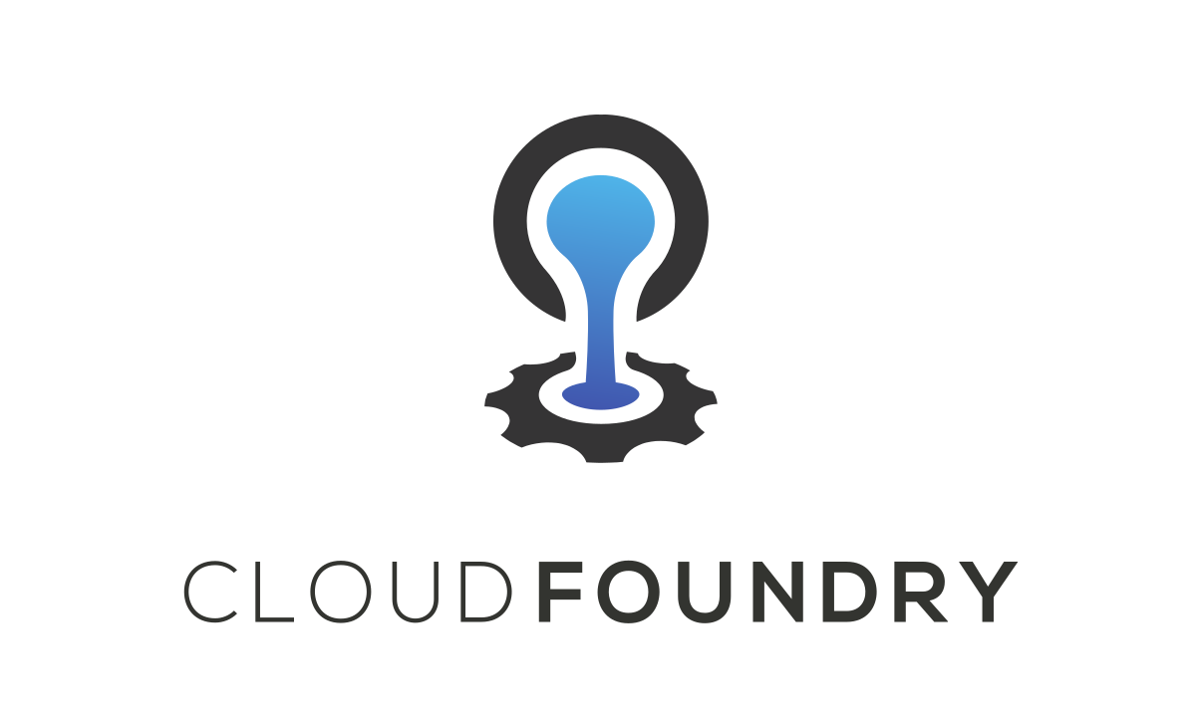

**1. Deployment on IBM Cloud Foundry:**

* *Activity:* Deployment on IBM Cloud Foundry was carried out seamlessly, leveraging the platform's capabilities for efficient resource management and scaling. The application was configured to run in a cloud environment, ensuring high availability and reliability.
* *Description:* Our deployment strategy involved containerization of the application using Docker, followed by deploying it to IBM Cloud Foundry. The platform's auto-scaling feature was utilized to handle varying traffic loads. Environment variables were set up to manage configurations securely.
* *Key Achievements:* The successful deployment resulted in improved application availability and performance. Challenges related to configuration and scaling were effectively addressed through collaboration with the IBM Cloud Foundry support team.

**2. Scalability and Resource Management:**

* *Activity:* To ensure scalability, we meticulously managed resources, balancing usage and cost-effectiveness. The resource allocation was optimized for varying user loads.
* *Description:* Resource optimization included efficient use of CPU, memory, and network resources. Load balancing was employed to distribute incoming traffic evenly across multiple instances. We closely monitored resource consumption and made adjustments as needed.
* *Key Achievements:* By optimizing resource usage, we achieved improved performance and cost efficiency. Our application could seamlessly handle increased traffic without compromising user experience.

**3. Performance Monitoring:**

* *Activity:* Ongoing performance monitoring was conducted to identify bottlenecks and areas for improvement.
* *Description:* We employed IBM Cloud Foundry's built-in monitoring tools to collect data on response times, request rates, and error rates. Continuous monitoring allowed us to proactively address performance issues.
* *Key Achievements:* Performance metrics revealed significant improvements in response times and a reduction in error rates. Monitoring also facilitated early issue detection, enabling timely corrective actions.

**4. Security and Compliance:**

* *Activity:* Rigorous security and compliance measures were implemented to safeguard user data and ensure adherence to industry standards.
* *Description:* Security practices included data encryption in transit and at rest, role-based access control, and regular security scans. Compliance checks were performed to align with regulatory requirements in our domain.
* *Key Achievements:* The project achieved a high level of security and compliance, instilling trust among users and ensuring data integrity. Regular security audits and compliance assessments were conducted to maintain these standards.

**5. Collaboration and Teamwork:**

* *Activity:* Effective collaboration was central to our project's success, with the project team working closely and cohesively.
* *Description:* The team maintained regular communication through collaboration tools like Slack and held frequent meetings to share updates and insights. A collaborative approach ensured knowledge sharing and quick issue resolution.
* *Key Achievements:* Teamwork led to smoother project progress, efficient problem-solving, and a cohesive team spirit, fostering a positive project environment.

**6. Documentation and Reporting:**

* *Activity:* Comprehensive project documentation was created, encompassing technical documents, user guides, and performance reports.
* *Description:* Documentation included architectural diagrams, API specifications, deployment procedures, and detailed reporting of performance and testing results. User guides were designed to make user interactions with the system intuitive and user-friendly.
* *Key Achievements:* The project's documentation and reports served as invaluable references for project stakeholders and users. This contributed to effective communication and understanding of project components.

**7. User Experience and Interface Design:**

* *Activity:* User experience (UX) and interface design played a pivotal role in making the project user-friendly.
* *Description:* We focused on designing an intuitive and responsive user interface. User journeys were mapped, and wireframes were created to improve the overall user experience. User feedback and usability tests were utilized for iterative design improvements.
* *Key Achievements:* The project's user interface design resulted in an enhanced user experience, reducing user friction and improving overall satisfaction.

**8. Code Development:**

* *Activity:* The code development phase involved writing, testing, and optimizing project components.
* *Description:* Collaborative coding efforts using Git and version control tools allowed for efficient code management. Code reviews and continuous integration ensured the codebase's quality and stability.
* *Key Achievements:* Code development milestones were consistently met, and a high-quality codebase was maintained. Continuous integration and automated testing contributed to code reliability.

**9. Testing and Quality Assurance:**

* *Activity:* Comprehensive testing and quality assurance efforts were employed to ensure a robust and reliable project.
* *Description:* Testing methodologies included unit testing, integration testing, and user acceptance testing. Quality assurance checks were carried out to identify and rectify any inconsistencies or issues in the project.
* *Key Achievements:* Rigorous testing and quality assurance led to a stable and error-free project, ensuring a reliable user experience.

**10. Future Development:** - *Activity:* The project team actively considered future enhancements and directions. - *Description:* We held discussions on potential features, scalability strategies, and user feedback implementation. A roadmap for future development was outlined, considering evolving user needs and technological advancements. - *Key Achievements:* Anticipating future development needs allowed us to plan for continued project growth and innovation. The roadmap provided a clear direction for the project's evolution.

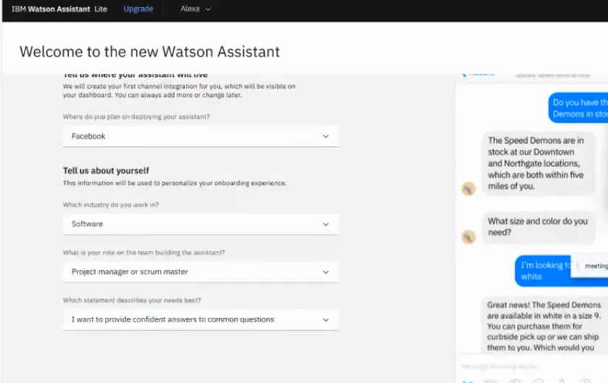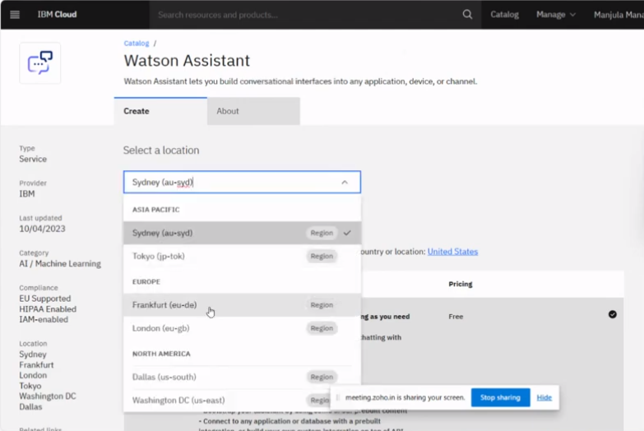

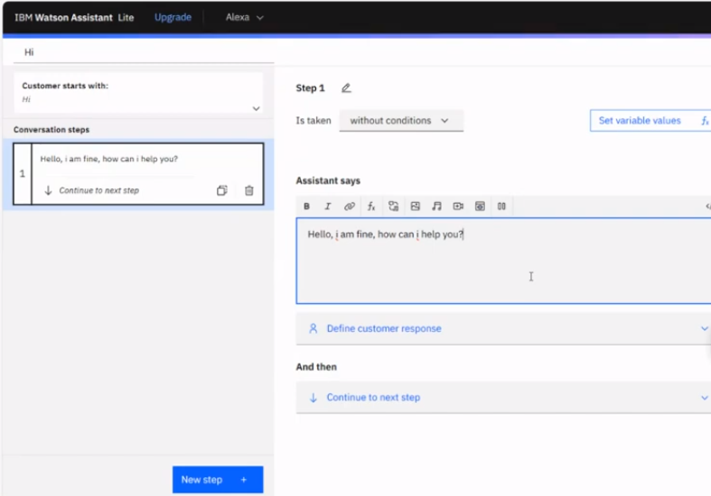

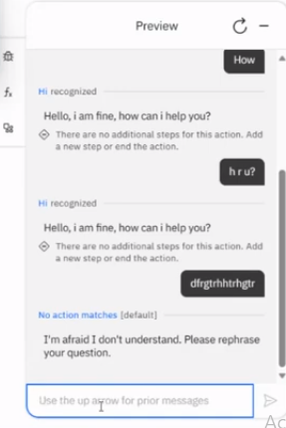

**Conclusion:**

*Summary:* Phase 4 marked significant progress in our technology project, with successful deployment on IBM Cloud Foundry, resource optimization, enhanced performance, and robust security measures. Effective collaboration, documentation, and design improvements contributed to a more user-friendly and reliable project. Testing and quality assurance ensured a stable codebase, and future development plans were laid out for ongoing project.